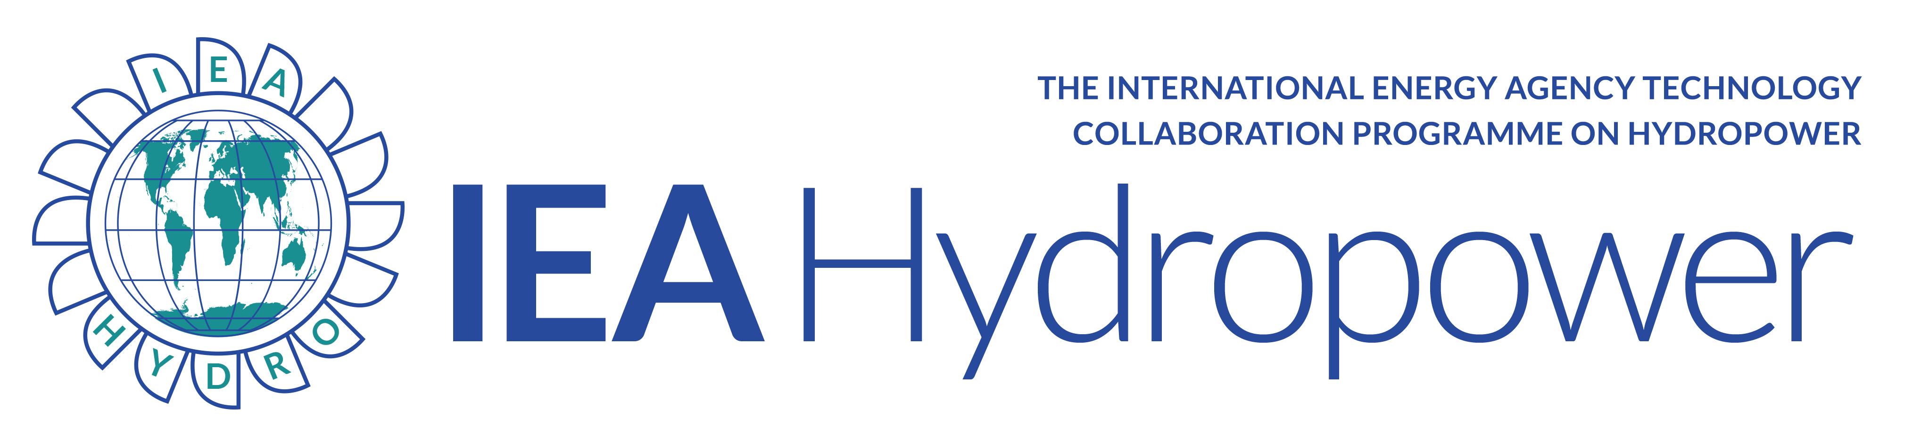

ANNEX IX

Summary of meeting held on 24 Sep 2020

- A couple of participants wanted to contribute with Case Studies on "Flood Control and Drought Management", to be included in the report. Templates will be distributed and the Operating Agents are looking forward to receiving case studies as soon as possible
- There will be an IEA Hydro session at the online Hydro 2020 conference on Wednesday 28 October "The role and value of hydropower in mitigating risks in a changing climate", including mainly case studies on Flood Control and Drought Management. See https://www.hydropower-dams.com/hydro-2020/ for more information and registration. Sessions will be pre-recorded, but discussions will be online.
- Niels Nielsen informed about a new Annex that are proposed by Japan: "Resilience of hydropower against flood disaster".
- This year's IEA Hydro ExCo meeting will most likely be an online meeting 10th November
- The IEA Renewable energy market Report will not have a special chapter on hydropower this year. Instead, IEA plan to issue a special report on hydropower in 2021
- IHA and DoE told us about a new initiative, the International Forum on Pumped Hydro Storage, to be launched in November
- Richard Taylor informed us about the EU-project "XFLEX". He was asking for anyone that had cost data for variable speed pump turbines
- Anton Schleiss informed about Hydropower Europe and their online workshop 12-13 October: “Addressing technical, environmental, and social challenges for hydropower as a catalyst for the clean energy transition in Europe”
- Misconceptions of hydropower were discussed. This topic was suggested for a factsheet, but it's probably better to inform about it in other ways
- DoE will follow-up with Japan on the methodology for valuing Pumped Hydro Storage
- We had once a plan to make a vocabulary for valuing hydropower services. This vocabulary can be a very long list, so it was suggested to include a selection of them in the White Paper II
- For the Case Studies on "Valuing Hydropower Flexibility in Evolving Electricity Markets", it was suggested to group cases in systems with similar characteristics (generation mix, amount of wind and solar generation, etc)
- Volunteers to help write the White Paper II or any other tasks are very much welcome!

